**Experiment No : 10**

**Title : Write a Python program to read keyboard input & print it to the screen.**

**Problem statements:**

Read your name, contact number, percentage from keyboard. And store them in appropriate variables. (use type conversion if needed). Print all stored data.

**Theory :**

**input ( ) :** This function first takes the input from the user and then evaluates the expression, which means Python automatically identifies whether user entered a string or a number or list. If the input provided is not correct then either syntax error or exception is raised by python.

**Code :**

name=input('enter your name : ')

contact_no=input('enter your contact no : ')

percentage=*float*(input('enter your percentage : '))

print('name is : ',name)

print('contact no is : ',contact_no)

print('percentages are : ',percentage)

**output :**

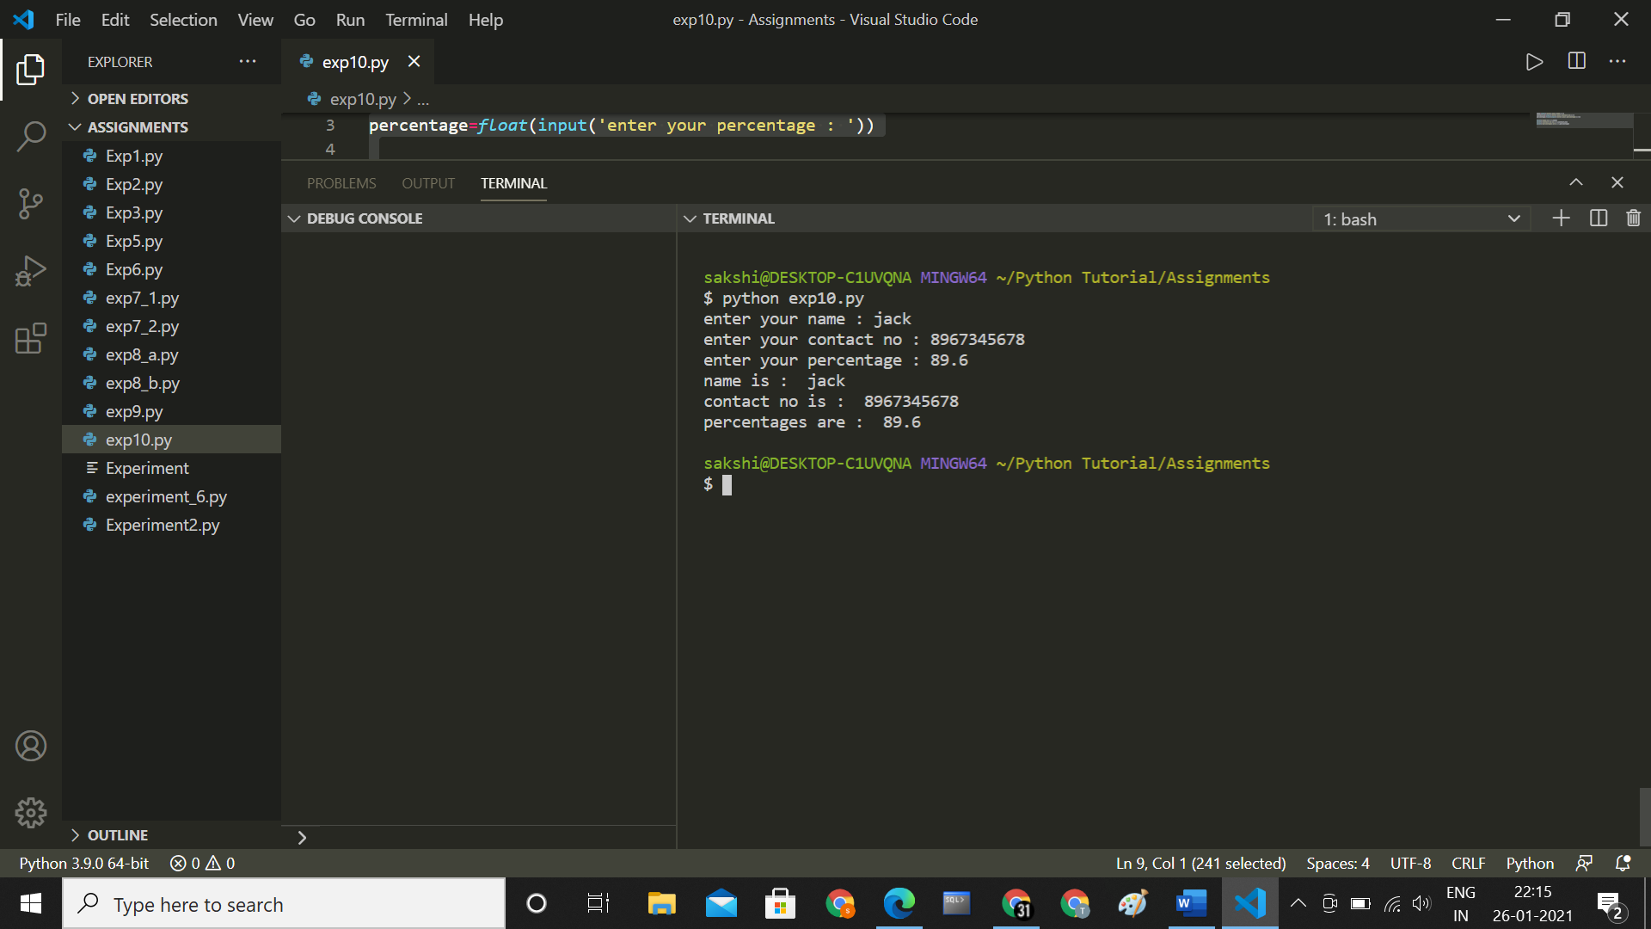

**Conclusion :**

**Thus we have understood how to read keyboard input & print it to the screen.**